Project From Moonshot to Mars
Plan of Approach

Remy Bien, Ruben Bras, Marvin Hiemstra,
Sebastiaan Groot, Wouter Miltenburg, Koen Veelenturf

22 February 2013
Version 1.0

Table of Contents
1. Introduction 3
2. Project Definition 4
2.1 Goal 4
2.2 Approach and phases 4
2.3 Results 5
2.4 Project conditions and limitations 5
3. Organisational structure 6
4. Product Dependencies 8
5. Planning 9
5.1 Project planning 9
6. Control mechanisms 10
6.1 Tolerances 10
6.2 Progress reports 10
6.3 Exception procedure 10
7. Project risks 12
Appendix A: Product description 14
Appendix B: Project planning 16
Appendix C: Product Dependencies 20

1. Introduction
As part of our minor Forensics Intelligence and Security our team will be working on Project Moonshot. The goal of this project is to provide federated access to high-performance grids using EAP-TTLS. Last year another team worked on the same project, and even though they came a long way, they did not finish the entire project. Their implementation worked up to a certain point but did not guarantee the privacy and security of the users' credentials. This year we will pick up on their work, and either improve up on, or rebuild their implementation to make sure user credentials are stored and handled securely. An extension of this work will be to connect the project to SURFconext. A similar project to log in to multiple services using only a single username and password.

2. Project Definition

2.1 Goal
The goal of this project will be enabling OpenSSH and WebDAV to support RADIUS authentication. During the development, the focus will be at following security principles and the creation of a standardised solution.

2.2 Approach and phases
The project is divided into three phases: initiation, building and delivery. The following table gives an overview of the deliverables and activities for each phase.

Phase | Product | Activity
Initiation | Presentation GSSAPI, RADIUS & EAP-TTLS | Literary study GSSAPI
Initiation | Presentation GSSAPI, RADIUS & EAP-TTLS | Study on RADIUS / EAP-TTLS tunnels
Initiation | Presentation GSSAPI, RADIUS & EAP-TTLS | Creating the presentation
Initiation | Test environment | Reading documentation from the previous team
Initiation | Test environment | Implementing their final product
Initiation | Plan of approach | Mapping the project
Initiation | Plan of approach | Writing the document
Building | Moonshot OpenSSH | Research and development
Building | Moonshot WebDAV | Research and development
Building | Integrating additional group attributes | Research and development
Building | Connecting VOMS with SURFconext | Research and development
Delivery | Final Report | Joining the documentation
Delivery | Final Presentation | Presenting the results of the project

2.3 Results
De following products together form the end result that will be delivered to NIKHEF:
- Presentation GSSAPI, RADIUS & EAP-TTLS
- Plan of Approach
- Moonshot OpenSSH
- Moonshot WebDAV
- Integrating additional group attributes
- Connecting VOMS with SURFconext
- Final Report
- Final Presentation

2.4 Project conditions and limitations
The scope of the project is the studying of existing literature and presenting the findings, the development of a solution that will enable the existing applications OpenSSH and WebDAV to authenticate users securely using RADIUS. The priority of the project, taking the time restrictions into account, is the delivery of solutions that can be presented and used on an international level. This priority has precedence over the delivery of all the products named above.

3. Organisational structure
In the period of running the From Moonshot to Mars Project, there will be a temporary organisation:

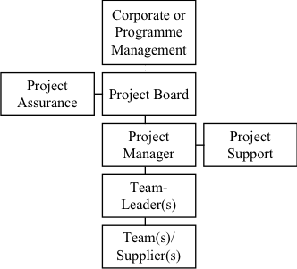
Corporate or Programme Management
Name | Role/Responsibility
Oscar Koeroo | Client

The client of the From Moonshot to Mars Project is mister Oscar Koeroo. Mr Koeroo is client on behalf of NIKHEF (The Dutch Institute for Subatatomic Physics) in Amsterdam.

Project Assurance
Name | Role/Responsibility
Sebastiaan Groot | Internal Team Coordinator
Koen Veelenturf | Internal Quality Assurance

During this project, the team will not get any Quality Assurance from ITopia, but will be responsible for their own Quality Assurance. The Project Assurance is responsible for monitoring the quality aspects of the project and the deliverables. The Project Assurance is independent from the Project Manager. The Project Assurance will keep the project in scope and makes sure that the goals will be achieved. The Project Assurance will report to the Project Manager.

Project Manager / Project Board
Name | Role/Responsibility
Sebastiaan Groot | Team Coordinator a.k.a. Project Manager

The Project Manager is responsible for the daily activities of the Project Team. The Project Manager is allowed to make decisions within the boundaries of the Project Board. The main responsibility of the Project Manager is to ensure the deliverables will be delivered in time, within budget and according to the quality standards.

Project Team
Name | Role/Responsibility
Remy Bien
Ruben Bras
Sebastiaan Groot | Team Coordinator
Marvin Hiemstra
Wouter Miltenburg
Koen Veelenturf | Internal Quality Assurance

The team is responsible for delivering the products according to specifications, described by the Client and Project Manager. The team reports to the Team Coordinator; the Team Coordinator reports to the Client and the (Hogeschool van Amsterdam) Project Board.

4. Product Dependencies
To give a good overview of the product dependancies, this chapter will describe the relationship between the individual products, which products run parallel and in which order the products are developed. See appendix C for a diagram depicting this information.

The project begins with the Plan of Approach, in order to properly define the scope, planning and project definition. Once this document is complete, research will start in the fields of Kerberos, RADIUS, GSSAPI and EAP-TTLS. These research results will be compiled into a presentation. After this product is finished, implementation of the test environment will begin, as well as a research in the possibilities of the previously researched subjects and writing of a network document will commence. The combination of the research and the test environment will result in an environment in which we can start development. During the development phase of the project, constant testing and debugging will be done. With the development environment ready, the team will start on moonshooting OpenSSH and WebDAV in parallel. When either of those is complete, that team will start with the next step of the project. In this step of the project, the team will look into the possibilities of connecting VOMS with SURFConext as well as a way to integrate additional group attributes into the moonshot applications. The documentation of the products combined with the earlier made network documents will then result in the final report.

5. Planning

5.1 Project planning
For a detailed, graphical planning, see appendix B.

Project part | Start | Deadline
Project from Moonshot to Mars | Mo 04-02-13 | Fr 14-06-13
Plan of Approach | Mo 11-02-13 | Fr 22-02-13
GSSAPI Research | Mo 11-02-13 | Th 21-02-13
Presentation GSSAPI | Fr 22-02-13 | Fr 22-02-13
Research of possibilities | Mo 25-02-13 | Fr 15-03-13
Network Documents | Mo 25-02-13 | Fr 08-03-13
Test environment | Mo 25-02-13 | Fr 15-03-13
Moonshot OpenSSH | Mo 18-03-13 | Fr 29-03-13
Moonshot WebDAV | Mo 01-04-13 | Fr 12-04-13
Integrating additional group attributes | Mo 15-04-13 | Fr 26-04-13
Connection VOMS with SURFconext | Mo 29-04-13 | Fr 10-05-13
Testing & Debugging | Mo 13-05-13 | Fr 24-05-13
Final Report | Mo 27-05-13 | Fr 07-06-13
For the description of the products, see appendix A.

6. Control mechanisms
This chapter describes which mechanisms will be applied to ensure that the project remains manageable and that the quality will be guaranteed.

6.1 Tolerances
The project team monitors and follows the project according to the planning described in the previous chapters. It is always possible, for all kind of reasons, that the team deviates from the plan. If this is the case the following rules will be retained:
- It is the intention that the projects will be finished according to the agreed end date. If this fails a new target will be defined with the client.
- If the scope of the project need to be changed, requested by the team or client, it is possible to do so. This request has to be communicated in a timely manner and needs to be approved by the client and in cooperation with the project-team. If the request is approved, the planning will be changed according to the approved request.
- If one of the sub-projects cannot be finished in the agreed deadline, the team will describe the proposed solutions in the final report of the overall project.

6.2 Progress reports
There will be weekly meetings between the client and the team. These meetings will take place on Fridays. During this meetings the progress will be reported with the client and when needed new targets will be defined. During the holidays or when a meeting is cancelled, the client will be reported via mail by the team leader of this project. When a deliverable is finished the client will be notified about this achievement and when a target is not achieved, or cannot be achieved on the agreed deadline the client will also be notified about this event. When it is the case that a deliverable cannot be finished on the agreed deadline, new targets will be defined with the client.

Furthermore, meetings will be held inside the project team to assure that everyone is aware what the other members are doing. During this meeting the project status will be checked and team leader will check if everyone is on schedule. Consequently doing this will result in less complications during the project and it also ensures that everyone is aware of each other. These meetings will also take place once in a week.

6.3 Exception procedure
The exception procedure occurs when the project can no longer succeed in the expected tolerance limits, regarding time and money. The exception procedure defines that in the first part a so called “reporting phase” will start. In this phase, an investigation will start into what could be the cause of this fault. All possible solutions and changes in order to succeed the project in the expected tolerance limits. In the second phase there will be made an appointment with the client. During this meeting the report that describes the reasons and causes of the fault will be presented to the client, the possible corresponding solutions will also be presented to the client. When the solutions are discussed, the next stage starts where the client and the team have to choose between one of the following situations:
- The project board will take measures to prevent/eliminate the cause
- The project board decides to not take action, because it thinks that the exceeding of tolerance will not take place
- There are concession to be made in respect of time, money quality or the projects that have to be delivered (the range of the project)
The first two situations will be reported during the meeting with the client (progress reports). The last situation will take place on the request of the project board and results in the creation of an exception plan with alternatives for dealing with the continuation of the project and for changing the planning.

7. Project risks
The following tables depict an overview of the as of now acknowledged threats to the project, including proposed countermeasures, the chance of occurrence and the rate of negative impact on the project (depicted on a scale of 1 to 5). The last column depicts the risk, which is chance*impact. In this way we can determine what threats need the most attention and/or resources.

During the project this list will be continually updated to account for new possible threats. If such an update occurs, it will be explicitly mentioned during the next meeting with the client.

Chance | Assigned number
Very small chance  Small chance  Intermediate chance  Reasonable chance  Big chance | 1  2  3  4  5
Tabel 7.1: Explanation of the rate of occurrence

Impact | Assigned number
Very small impact  Small impact  Intermediate impact  Big impact  Great impact | 1  2  3  4  5
Tabel 7.2: Explanation of the impact

Threat | Countermeasures | Chance | Impact | Risk
The project gets canceled. | Communicate with the client as to the reason of the cancellation. Try to get the project back on it's feet again. If this proves impossible, try close the project to the satisfaction of both parties. | 1 | 5 | 5
Work is done outside of the scope of the project. | Assign an team member to guard the scope and ensure all work done is absolutely necessary. Update planning to account for lost time. | 2 | 4 | 8
Threat | Countermeasures | Chance | Impact | Risk
Product does not meet the client's expectations. | Inform client of the state of the products during the meetings to keep to set the correct expectations and if needed update the scope of the project.  Ask the client if an updated product should be made, or alternate solution should be found. | 2 | 4 | 8
Longterm absence of one or more team members. | Update the planning and scope of the project, depending on the duration of the absence. Re-assign roles in the team if necessary. | 2 | 3 | 6
Employees struggle to understand the hard/software used in the project. | Take extra time to familiarize at least one person on the team with the hard/software, who can then relay this information to others. Consult with the client and other sources for help if needed. | 3 | 4 | 12

Appendix A: Product description
Productname / -number | 01 | Presentation GSSAPI, RADIUS & EAP-TTLS
Description | Presentation on the inner workings and applications of the GSSAPI, RADIUS protocol and EAP-TTLS protocol.
Duration (days) | 18
Deadline | 28-02-2013

Productname / -number | 02 | Plan of Approach
Description | A document covering the subjects of project definition, global planning, project scope, risk analysis and other information related to the project.
Duration (days) | 12
Deadline | 22-02-2013

Productname / -number | 03 | Moonshot OpenSSH
Description | An implementation method of OpenSSH using the implementation principles of Project Moonshot to allow federative authentication and authorization.
Duration (days)
Deadline

Productname / -number | 04 | Moonshot WebDAV
Description | An implementation method of WebDAV using the implementation principles of Project Moonshot to allow federative authentication and authorization.
Duration (days)
Deadline

Productname / -number | 05 | Integrating additional group attributes
Description | A method of using additional group attributes in the authentication and autherization proccess of OpenSSH and WebDAV
Duration (days)
Deadline

Productname / -number | 06 | Connecting VOMS with SURFconext method
Description | A method of connecting the existing VOMS and SURFconext environments to create a unified way of obtaining (group) data from both systems.
Duration (days)
Deadline

Appendix B: Project planning

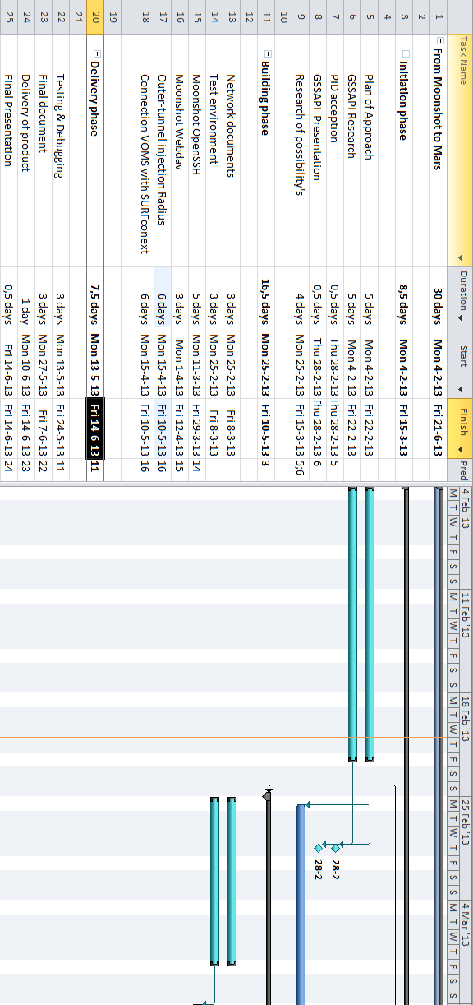
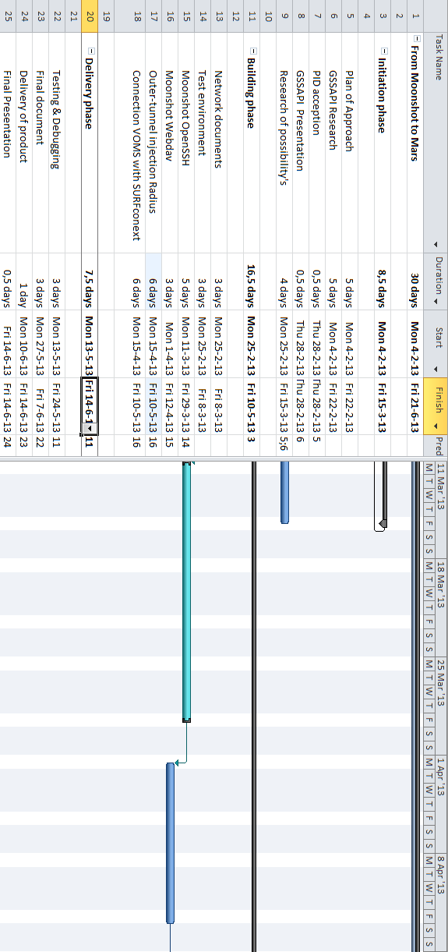
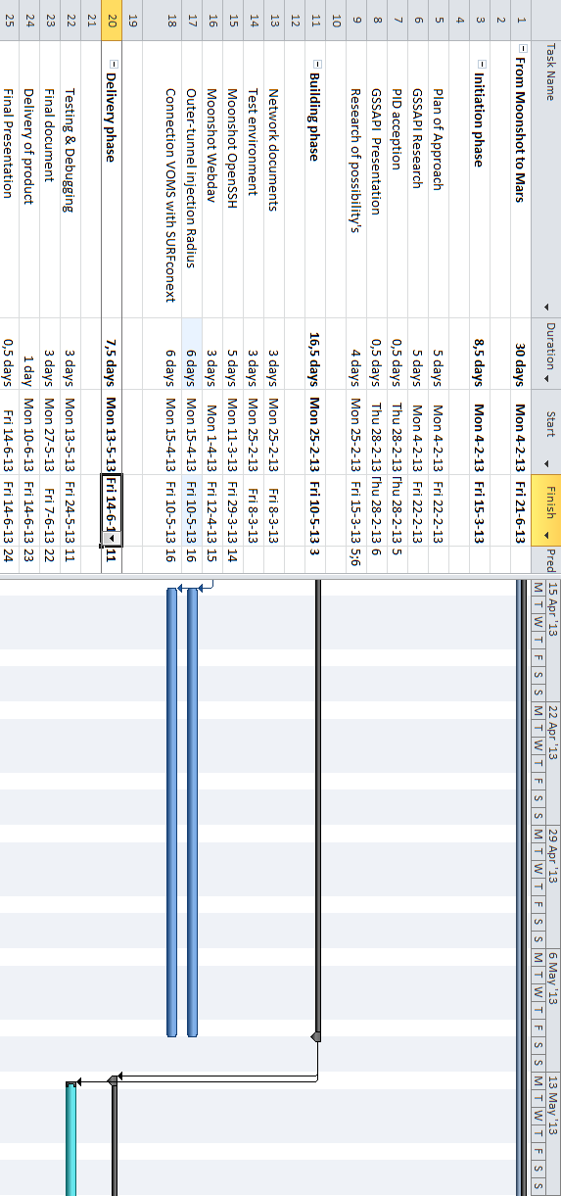
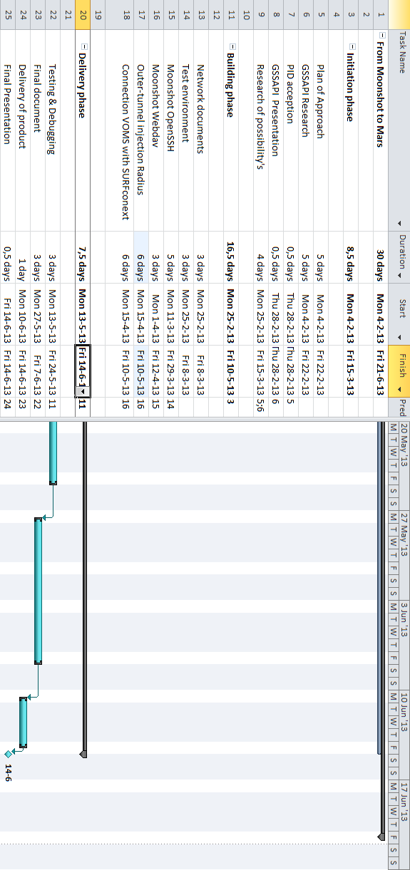

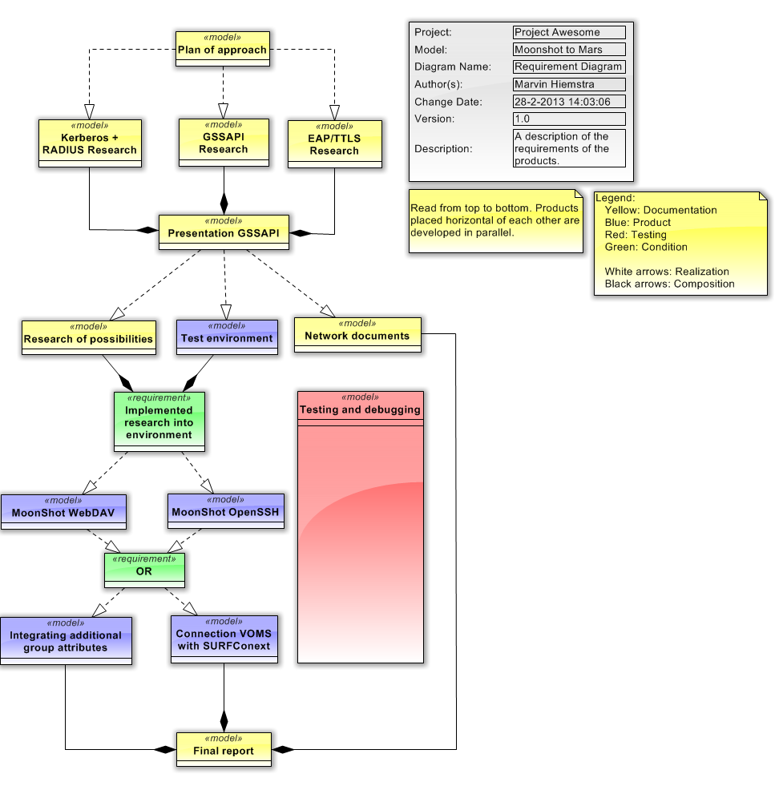
Appendix C: Product Dependencies

